**Ecommerce Sales SQL Queries**

**-- Calculate Total Orders--**

Select

count(CustomerID) as Total_Orders

from ecommercet;

Result: 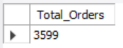

**-- Calculate Total Sales--**

Select

concat(round(sum(Total)/1000,1),"K") as Total_Sales

from ecommercet;

Result: 

**-- Total Sales In Process--**

Select

concat(round(sum(Total)/1000,1),"K") as Total_sales_InProcess

from ecommercet

where OrderStatus = "In Process";

Result: 

**-- Total sales for completed orders--**

select

concat(round(sum(Total)/1000,1),"K") as Total_sales_completed

from

ecommercet

where

OrderStatus="Completed";

Result: 

**-- Total Returned Orders--**

select

count(InvoiceNumber) as Total_Returned_Orders

from ecommercet

where OrderStatus="Returned";

Result: 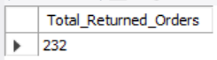

**-- Total Cancelled Orders--**

Select

count(InvoiceNumber) as Total_Cancelled_Orders

from

ecommercet

Where

OrderStatus="Cancelled";

Result: 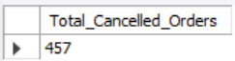

**-- Orders of Top 10 countries--**

Select

Country as Countries,

count(InvoiceNumber) as Orders

from ecommercet

group by 1

order by 2 desc

limit 10;

Result: 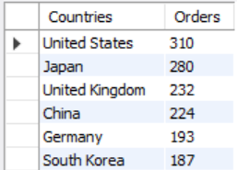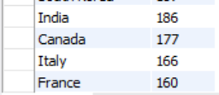

**-- Total Orders by Devices--**

Select

Device as Devices,

count(InvoiceNumber) as Total_Orders

from

ecommercet

group by

Devices

Order by

Total_Orders desc;

Result: 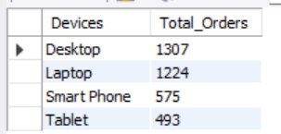

-- Total Orders by Traffic Sources--

Select

TrafficSource as Traffic_Source,

count(InvoiceNumber) as Total_Orders

from

ecommercet

group by

TrafficSource

Order by

Total_Orders desc;

Result: 